Detecting Fake vs Real News using Machine Learning



**Software Engineering Project: EEC 626**

**Developers Guide**

Anubhuti Dayal – 2824826

Oyindoubra Timi – 2822556

Developers Guide

# Please find Execution Steps for the project “Detecting Fake vs Real News”

* Get the Fake news detection code folder Downloaded on your machine and unzip it

1. Download and install PyCharm or any python supported IDE. For this project, PyCharm and VS Code were used.

You can follow this link - <https://youtu.be/qC6-Uv9m_Ls>

<https://www.jetbrains.com/pycharm/download/#section=windows>



1. Open the project folder in the PyCharm environment on your machine after installation
2. Open a terminal on the IDE
3. If jupyterlab is not already installed in your system, type “pip install notebook” and hit “Enter” on your keyboard

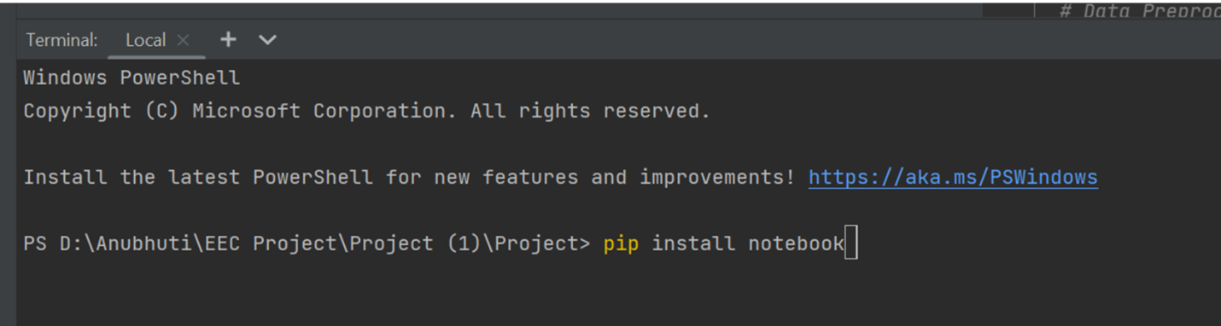

1. Next, type “jupyter notebook” and hit “Enter.” This should open a tab on your browser that shows all the documents and files in the project folder
2. Scroll to “FakeNews.ipynb" file and click on it. This should open in a new tab

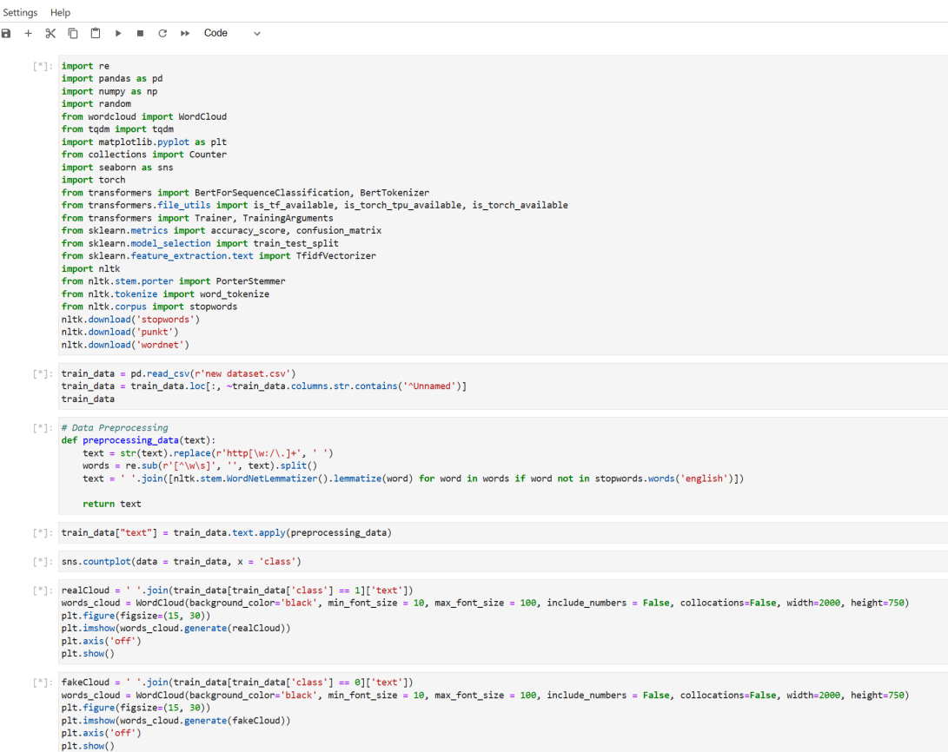

* Change/update data Path in the code

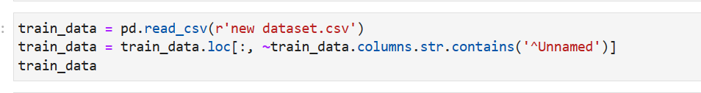

1. Run each cell. Some cells might take hours or days to finish running depending on the speed of your device
2. After running the last cell, an input box will be displayed. Input your news in the box and hit “Enter”

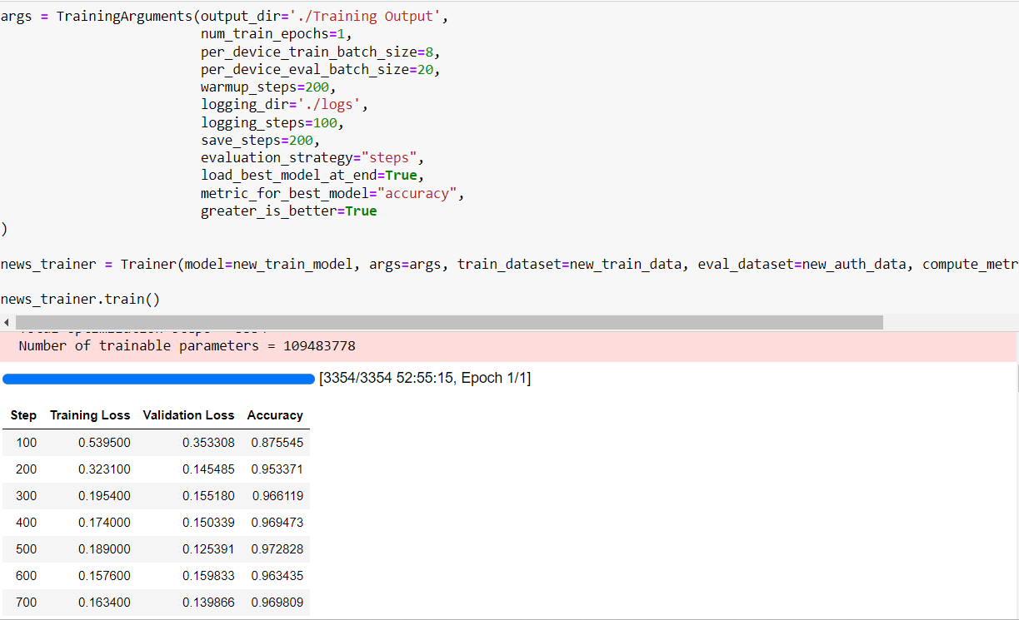

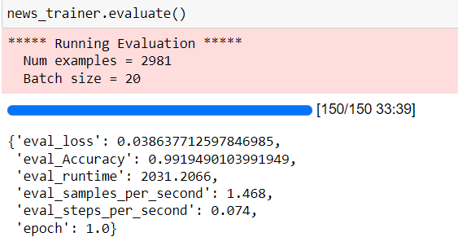

1. The result will be displayed to tell you if the news is real or fake

